**F. Y. B. Tech Academic Year 2021-22**

**Subject:** Programming and Problem Solving **Trimester:** 2

**Name:** Shreerang Mhatre  **Division:** 11

**Roll No:** 111056  **Batch:** K3

**ASSIGNMENT NO: 7**

**AIM:** Write a C program to accept student details and display their result using array

of structures.

**OBJECTIVE:**

1.To understand basics of structures in C programming.

2. To learn array of structures.

**THEORY:**

**What is a structure and its use**

Arrays allow to define type of variables that can hold several data items of the same kind. Similarly, structure is another user defined data type available in C that allows to combine data items of different kinds.

E.g., Structures are used to represent a record. Suppose you want to keep track of your books in a library. You might want to track the following attributes about each book −

• Title

• Author

• Subject

• Book ID

**Syntax and example of structure**

Structure- A structure is a user defined data type in C. A structure creates a data type that can be used to group items of possibly different types into a single type.

The general syntax for a struct declaration in C is: struct tag_name {type member1; type

member2; /* declare as many members as desired, but the entire structure size must be known to the compiler. */ };

Example- ‘struct’ keyword is used to create a structure. Following is an example.

struct address

{ char name[50]

char street[80]

char city[20]

Int pin };

**Syntax and example of structure and array of structure**

Array of structure - In programming, structure is a composite datatype with a collection of variables. These variables can have different data types and collectively form a structure of a composite datatype. An array of structures is a sequential collection of structures. With structures, you can store mixed record types, and with an array supporting this, you can have a list of mixed record types.

The following example shows the usage of array of structures in C programming :

struct book

{

int pages;

char author [30];

float price;

};

**Implementation:**

**Platform: 64 –**bit Windows 10**.**

**Technology:** Open Source Visual Studio Code

**ALGORITHM :**

**Step 1) Start**

**Step 2) Define a structure student with variables for first name, roll**

**number,and marks.**

**Step 3) Then, create a structure variable stu[10] which is an array.**

**Step 4) Define the main function.**

**Step 5) Initialize i=0 in a for loop which runs till n elements.**

**Step 6) Next, take user input for first name, roll number, and marks.**

**Step 7) Finally, define another loop for displaying information of the five**

**students.**

**Step 8) Stop.**

**Flowchart:**

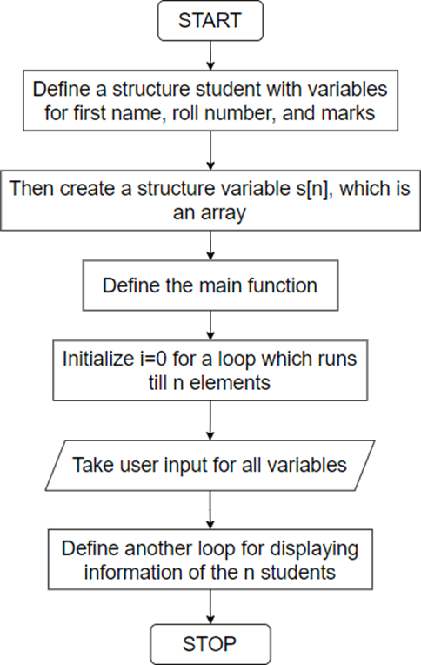

**Visual Studio Code :**

**Code for given program:**

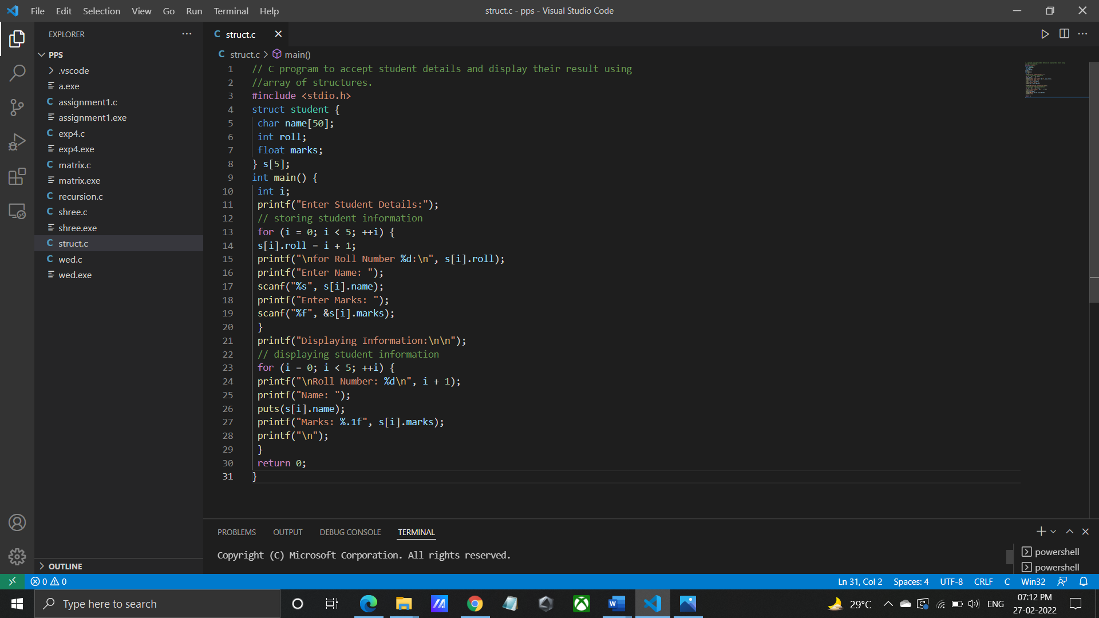

**Output for given program:**

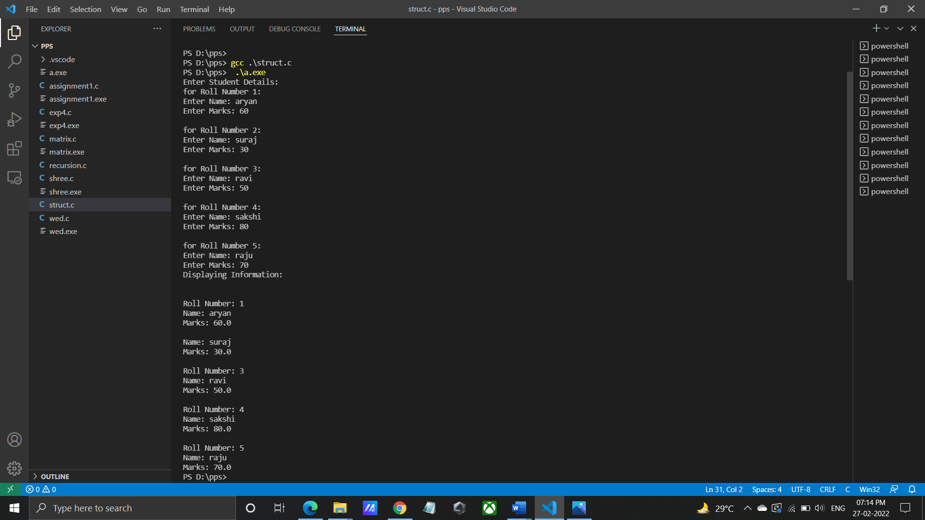

**Program/ Code:**

// C program to accept student details and display their result using

//array of structures.

#include <stdio.h>

struct student {

char name[50];

int roll;

float marks;

} s[5];

int main() {

int i;

printf("Enter Student Details:");

// storing student information

for (i = 0; i < 5; ++i) {

s[i].roll = i + 1;

printf("\nfor Roll Number %d:\n", s[i].roll);

printf("Enter Name: ");

scanf("%s", s[i].name);

printf("Enter Marks: ");

scanf("%f", &s[i].marks);

}

printf("Displaying Information:\n\n");

// displaying student information

for (i = 0; i < 5; ++i) {

printf("\nRoll Number: %d\n", i + 1);

printf("Name: ");

puts(s[i].name);

printf("Marks: %.1f", s[i].marks);

printf("\n");

}

return 0;

}

**INPUT:**

Enter Student Details:

for Roll Number 1:

Enter Name: aryan

Enter Marks: 60

for Roll Number 2:

Enter Name: suraj

Enter Marks: 30

for Roll Number 3:

Enter Name: ravi

Enter Marks: 50

for Roll Number 4:

Enter Name: sakshi

Enter Marks: 80

for Roll Number 5:

Enter Name: raju

Enter Marks: 70

**OUTPUT:**

Displaying Information:

Roll Number: 1

Name: aryan

Marks: 60.0

Roll Number: 2

Name: suraj

Marks: 30.0

Roll Number: 3

Name: ravi

Marks: 50.0

Roll Number: 4

Name: sakshi

Marks: 80.0

Roll Number: 5

Name: raju

Marks: 70.0

**CONCLUSION:** Thus implemented the program to accept student details and display their

result using structures.

**FAQ:**

1. Explain difference between Structure and Union?

ANS: A structure is a user-defined data type available in C that allows to combining data items of different kinds. Structures are used to represent a record.

Defining a structure: To define a structure, you must use the struct statement. The struct statement defines a new data type, with more than or equal to one member.

A union is a special data type available in C that allows storing different data types in the same memory location. You can define a union with many members, but only one member can contain a value at any given time. Unions provide an efficient way of using the same memory location for multiple purposes.

Defining a Union: define a union, you must use the union statement in the same way as you did while defining a structure union statement defines a new data type with more than one member for your program.

1. How to access Structure variable?

ANS: To access any member of a structure, we use the member access operator (.). The member access operator is coded as a period between the structure variable name and the structure member that we wish to access. You would use the keyword struct to define variables of structure type.